Salvador Cortes Soancatl

Final Class Project – Summer 2021

EE 523: Mobile Applications for Sensing and Control

August 19, 2021

**Final Class Project Report**

For my final class project, I initially wanted to design an app that solar panel owners would use to monitor the efficiency of their solar panels, based on a cleanliness of the solar cells. Via this app the end user would be able to schedule appoints with my company (made up) and track maintenance of their solar panel. My plan was to have the solar panel take a picture their solar panels every month and the app’s algorithm would calculate the efficiency of the solar panel. This proved tricky so in the middle of the quarter I decided to switch to a new application. However, I feel that there is a market for this application so I will invest more time into this later.

The Android Application that I worked on for this project is the following I created an application for my new business Ninja Auto Detailing. I only just started this business about a month ago, have a couple customer which I clean their cars on a regular basis and is something that I enjoy now and plan on expanding in the future. The reason for the application is very simple, I wanted a professionally designed application which customers can use to monitor their car as it is cleaned, for customers to book appointments an lastly as a way for my customers to connect with my company.

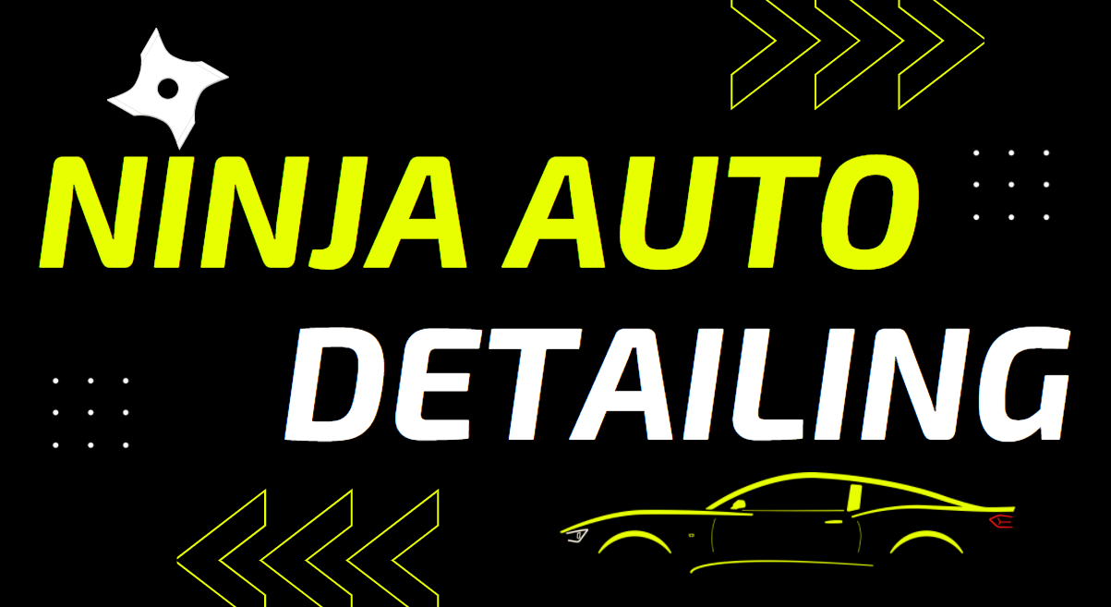

Figure 1: Ninja Auto Detailing Business Card

Figure 1. above is a picture of my business card, the phone application should follow this color scheme and theme. The theme that we are going for here is minimalistic design and a green earth friendly tone. For the application I also went ahead and drafted some requirements which the application must have.

The below list is the high-level app requirements:

* App should have a home page; home page should include button for scheduling service appointment
* App should have a page which details services offered by N.A.D
* App should include a gallery page for outstanding work done
* App should include an about us page and settings page with simple options for changing app settings
* App users/customer should have an option for login into their account
* New app user should have the function to create new account
* App must be easy to use and bug free

The application was developed using Android Studio, a free app development IDE too by google. As the app is a business app which will not only support customers with scheduling appointments it should also promote the business with an appealing design. Android Studio supports such design usingtheir **Navigation Drawer Activity** which allows you to have a menu bar called your **drawer** and initialize new pages or navigation activities. This feature made it easy for the app to be developed and to organize the different screens that were implemented in the appl. Below is a picture of the drawer menu bar discussed.

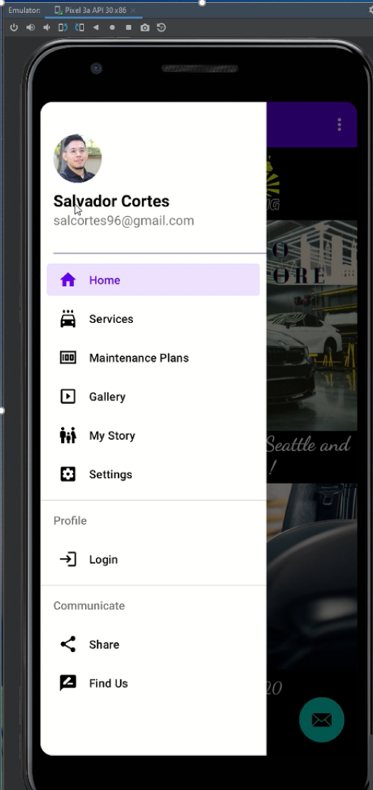

Figure 2: Main Drawer Activity

Each one of the drawer activities has its own .xml activity page which is unique to the feature demoed. Below is the homepage which is the default page for when the application is launched. Notice the menu bar on the top left corner of the page an options button at the right top corner which directs you to the settings page.

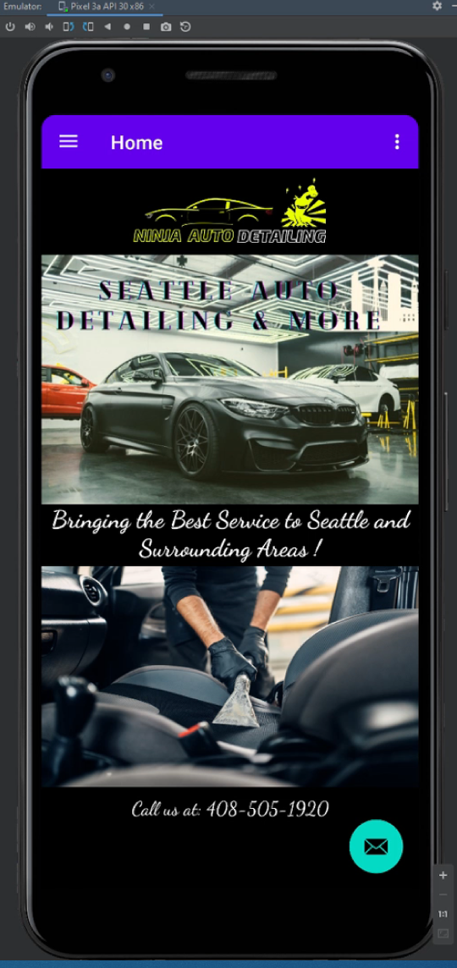

Figure 3: Home Page on App Launch

The front-end part of the app was developed as shown below. Next, I will discuss more about the back end.

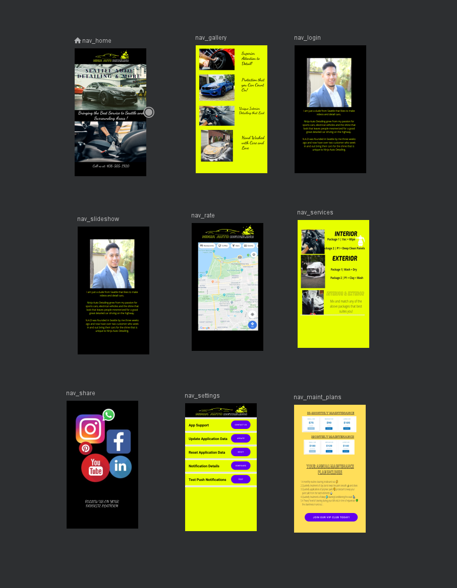Figure 4: Other main activity pages used in application

In the back-end side of things I will focus more on the side of the architecture as this is more important than going over the actual code. So to start the navigation drawer is a UI panel that the app’s main navigation menu. It provides actions preferable to the users like example changing user profile, changing settings of the application. Below Figure 4 breaks down the structure for this application. As you can see it is s completion of .kt and .xml files. For every fragment drawer page a UI folder was created to house special variables and differentiate from the different fragment’s for say when in the future one would like to make a change to a single page one can go that specific fragment folder and modify as they please without running the risk to altering any other method. In the similar manner this app required of different supporting vector files, these files are shown in the image below as app resources, Android Studio makes it really easy to upload and design specific icon vectors. 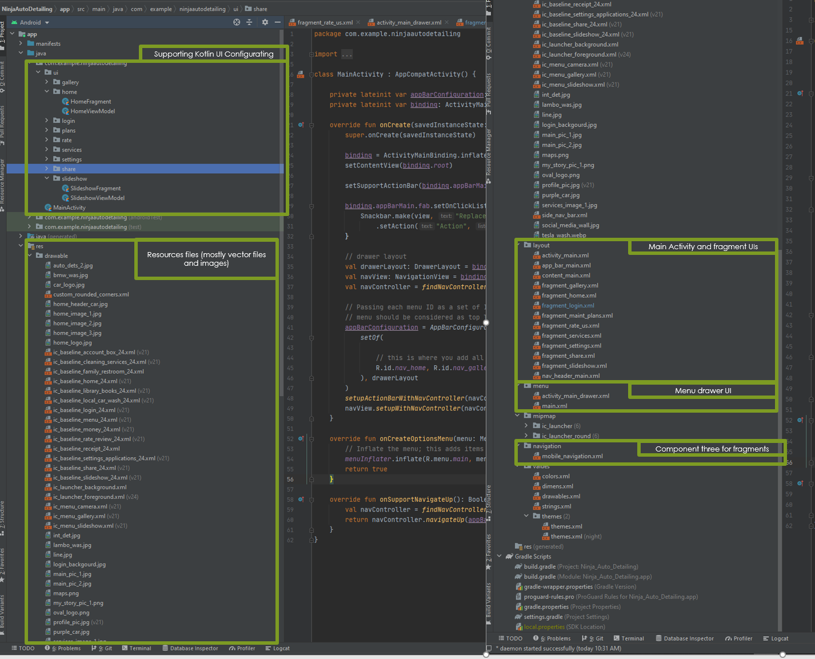

Figure 4: Other main activity pages used in application

Lastly the final project source files can be found here under the Ninja Auto Detailing directory:

<https://github.com/salcortes96/523-Assignments.git>

Project Updates 8/1/2021

In term of project updates, I have decided to break down my design into two components, the software aspect of it and then the hardware aspect of it. While it my project may require minimal hardware work, I have planned for the case where it might be to my benefit to just plan for it. If at the end of the day I decide that I do not need an external sensor this would reduce my app development timeframe by a lot.

Hardware Updates

* In Lecture 5, we learned of different sensor that come complementary with most smart phones. A sensor that caught my attention is an ambient light sensor, which I can use for my project. How the sensor works is very easy, the display of the device automatically brightens when sunlight shines to it, the display then dims in darker environments.
* I can use the sensor for many applications but one that I am interested in is using the sensor for measuring the cleanliness of a solar panel. This is very easy as one can use their smart phone to measure how dirty it is, I have a diagram below that showcases how this works.

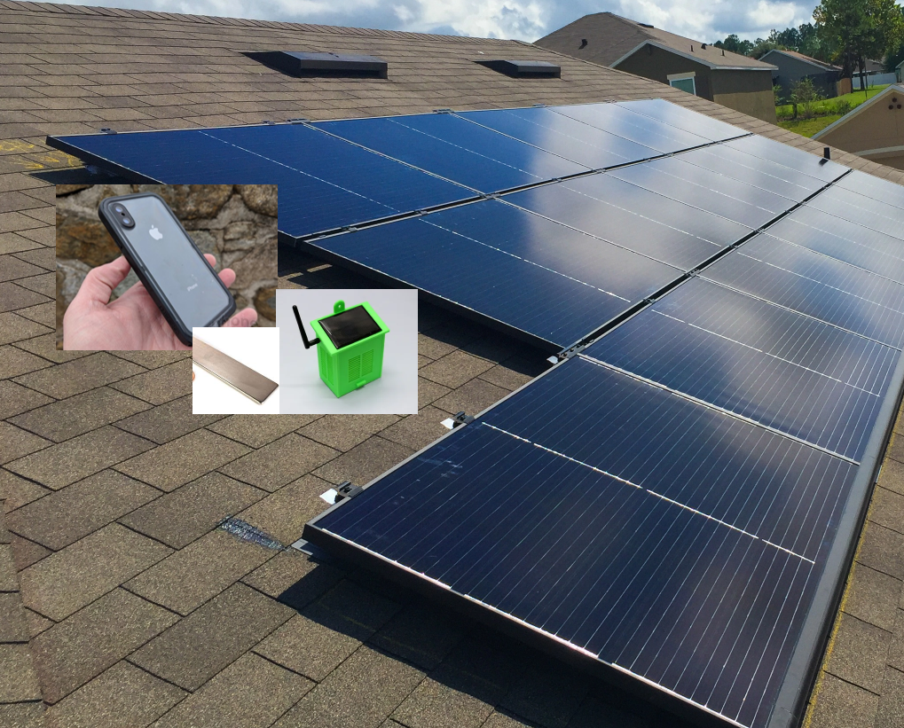

Software Updates

* In terms of the software, it is still lacking I have to learn how to use the light proximity sensor and be able to correlate the sunlight received by the sensor to a dirtiness value found in the solar panels. This will require for me to do some in home testing of how-to device an algorithm for measuring the dirtiness and efficiency of a solar panel. In terms of the GUI it is still in works.

Project Proposal

* Brief Description
  + For my project I would like to design a Solar Panel Cleaning App that allows solar plane owners determine the dirtiness of their solar plane via a phone app and a sensor device that is installed on their solar system. This app will allow users to monitor the efficiency of their solar panel as it directly correlates to the cleanliness of the panels, it will also allow for trend monitoring of savings and maintenance service.
  + Add-ons to the app include capabilities of scheduling a solar panel cleaning appointment with one of their trusted local solar panel cleaning services.
  + Side Note, I plan on opening my own solar panel cleaning service soon so this app will allow me to get my foot in the door when it comes to the solar panel cleaning business. In the same manner.
  + Below is a quick picture of how efficient solar panel may be once cleaned and maintained.

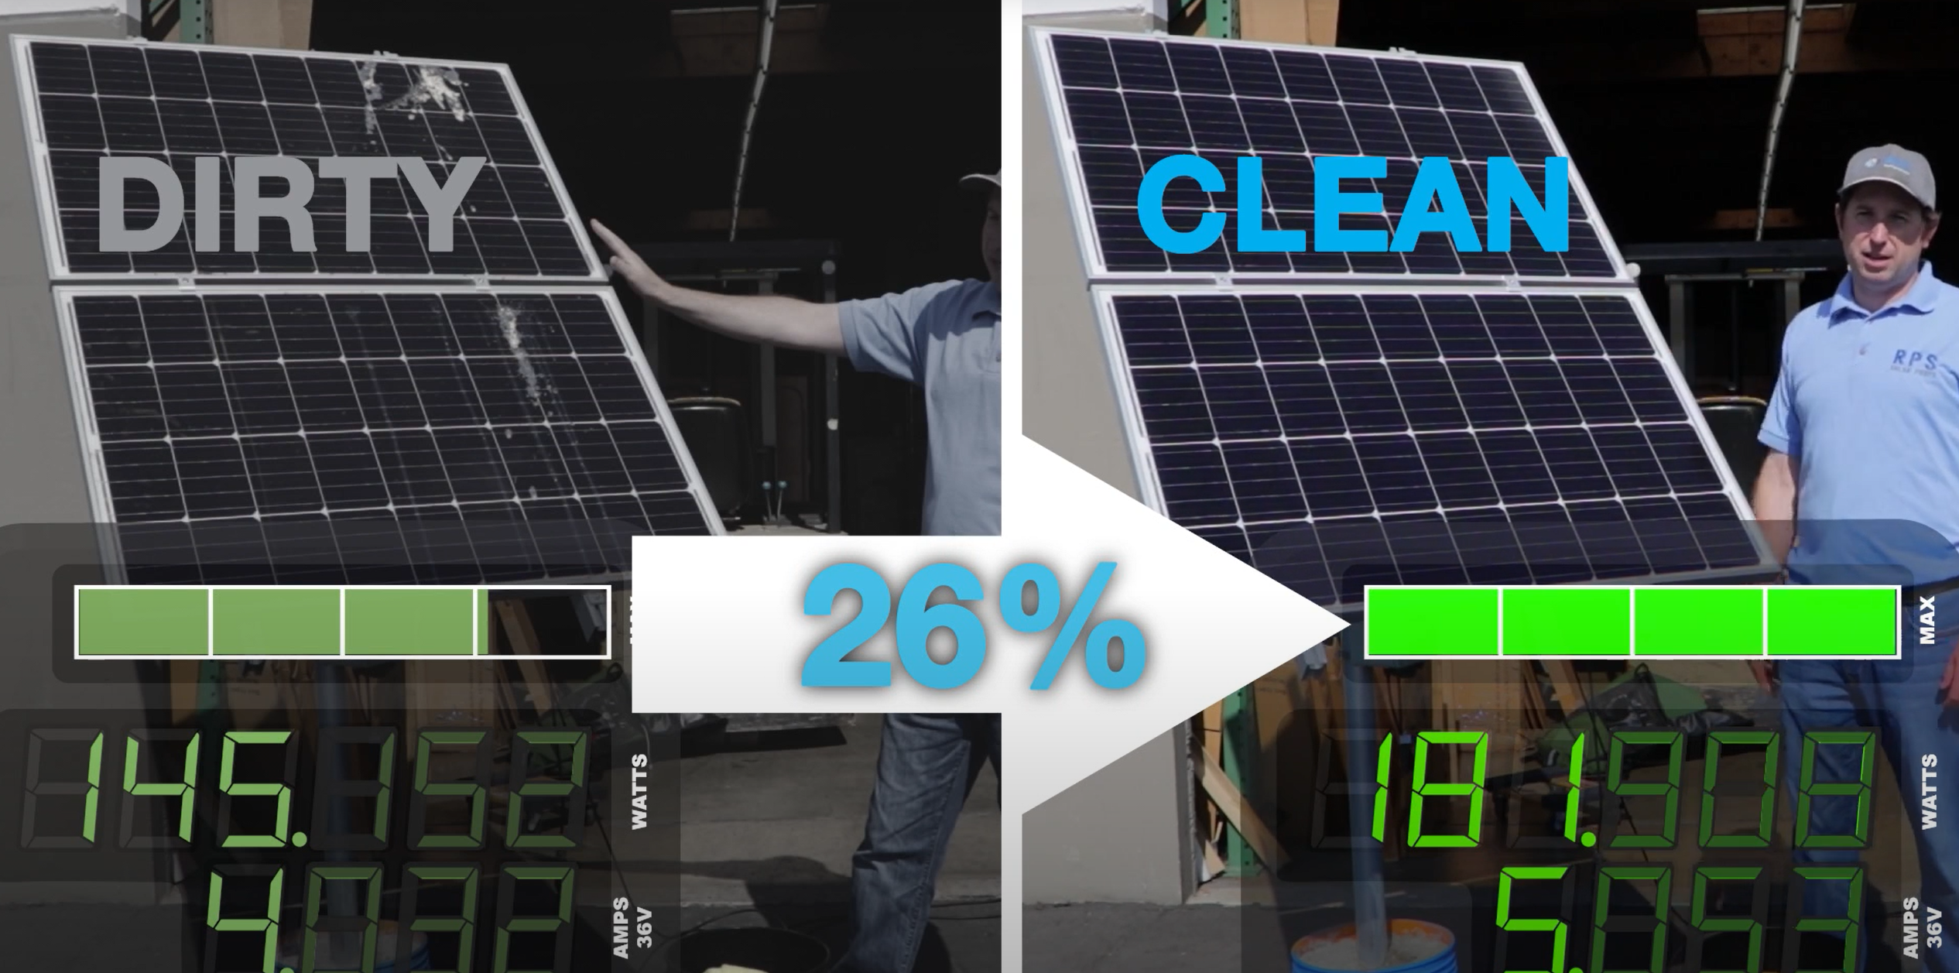

* Main Functionality
  + The main functionality for my app will be to monitor the dirtiness of solar panels. I am still unsure if this will be done via an external sensor that will need to be mounted on the solar panel system. Or something more like the owner will need to go on their roof, take pictures of their solar panels, and then upload them so that our software and algorithms review this data and determine how dirty they are and if the solar panels require maintenance.
* Initial User Interface

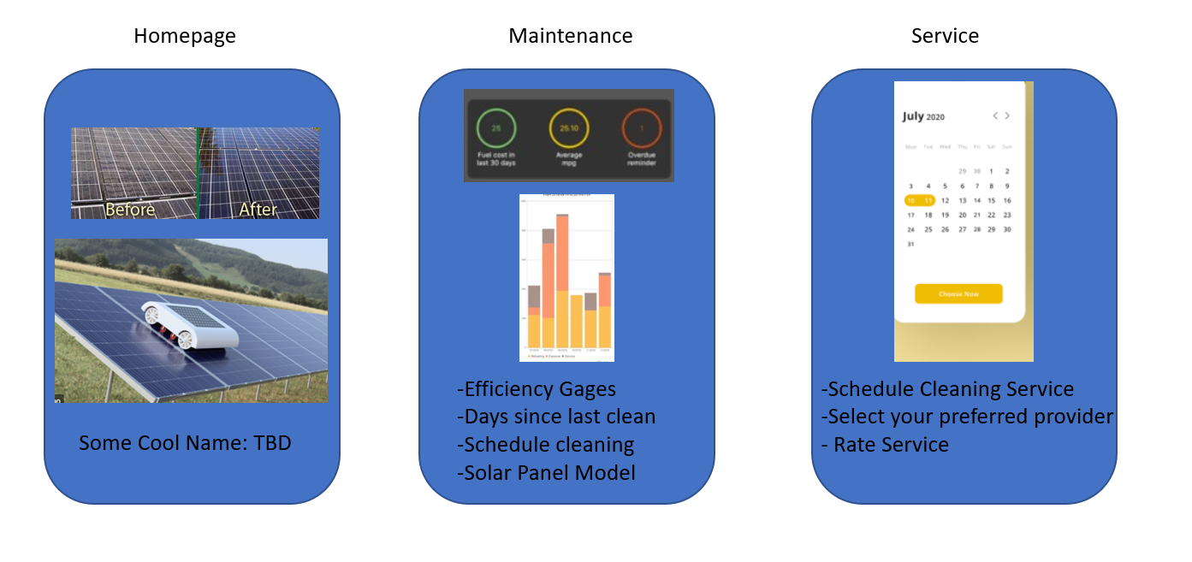

* Sensor to Be Used
  + Not sure if there is a sensor that I can use for my application yet… I might use a large photoresistor which is installed on the solar panes and as they become dirty the restive sensitivity changes. Another idea I have is of having the owner go on their roof and taking a picture of their solar panels, and having an algorithm that tells them how dirty the roof, the effective efficiency and also if maintenance is due.
* Hardware Components
  + Simple analog photoresistors. I will need to use an ADC as well to convert the analog values to digital values that I can manipulate. I plan on also using the class provided Bluetooth IC to transmit my data wirelessly to the smartphone.

